# Student Grade Calculator – Documentation

***Student Grade Calculator is a simple java application, designed to calculate the final grade for each Student based on the scores received for each group of assessments.***

***This Documentation is to assist in using the application.***

# Adding a Student and Their Grades:

First, we need to enter a **Student Name;** Student Name can be any combination the user desiers;

* FIRSTNAME, LASTNAME
* LASTNAME, FIRSTNAME
* LASTNAME, INITIAL, FIRSTNAME
* ETC

Now we can enter the Student's marks for each group of assessments:

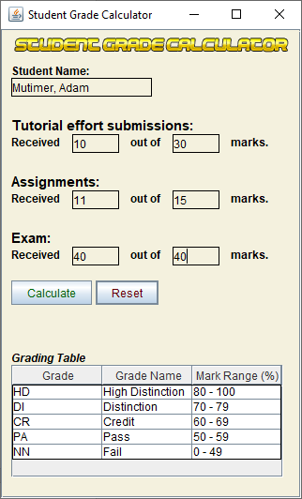

When all Data has been entered selected the "Calculate Button."

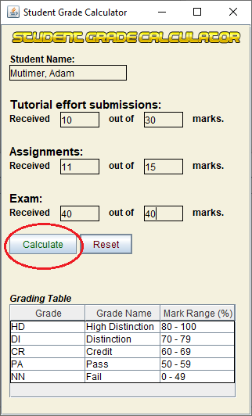

***If incorrect information put into these fields, Validation Errors will be presented an error message, that should assist in resolving the issue:***

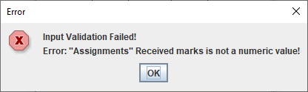

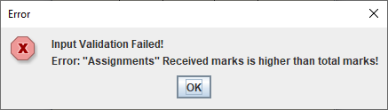

***If valid information is provided, the user will be presented with a message similar to this:***



The Students grades will now appear in the "Results" Window:

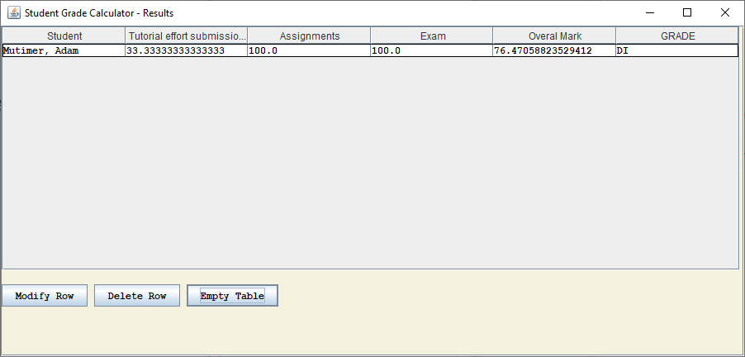

The user may now continue to enter more Students into the Main Window Form as it has reset awaiting new input:

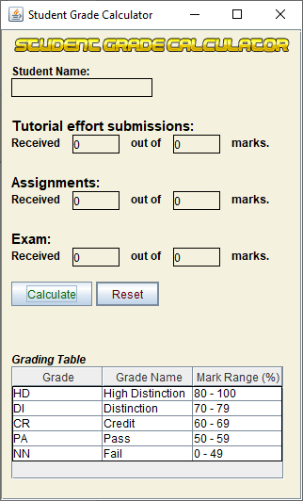

# Modify a Student and Their Grades:

On the "Results" window, select the row containing the Student you wish to modify:

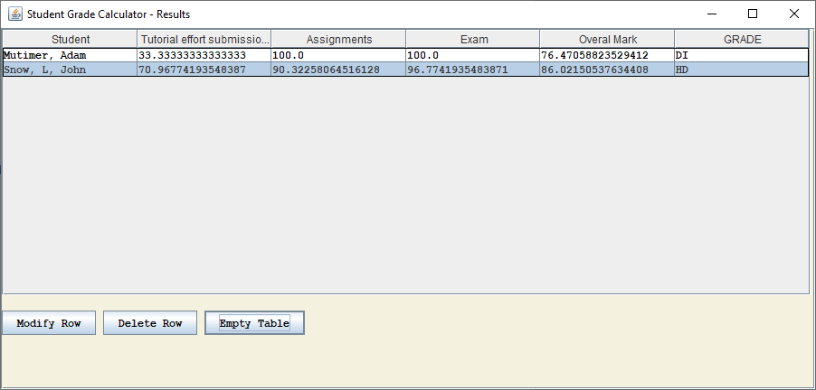

Then Select "Modify Row" button:

The "Main" application window will now show the students information, and the Student will no longer be in the "Results" window:

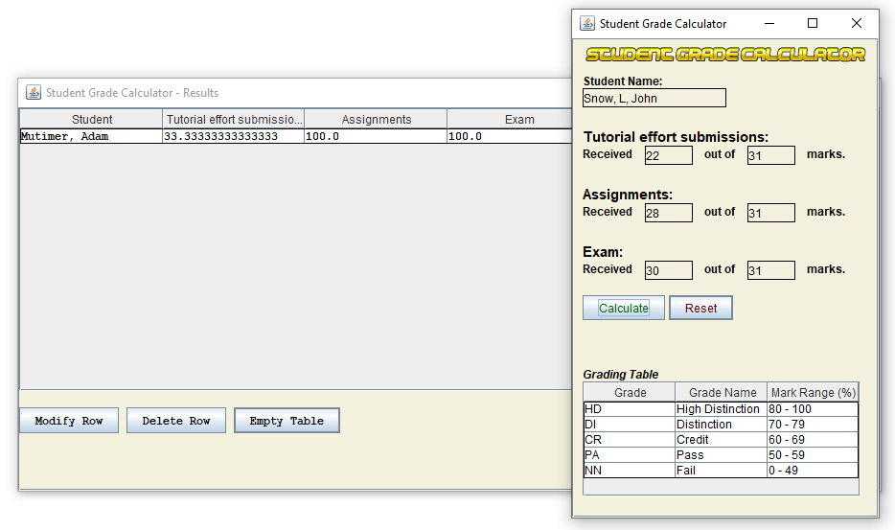

Now the user may edit the information, as usual, then when completed, select the Calculate button as normal, and the Student will be added to the results table

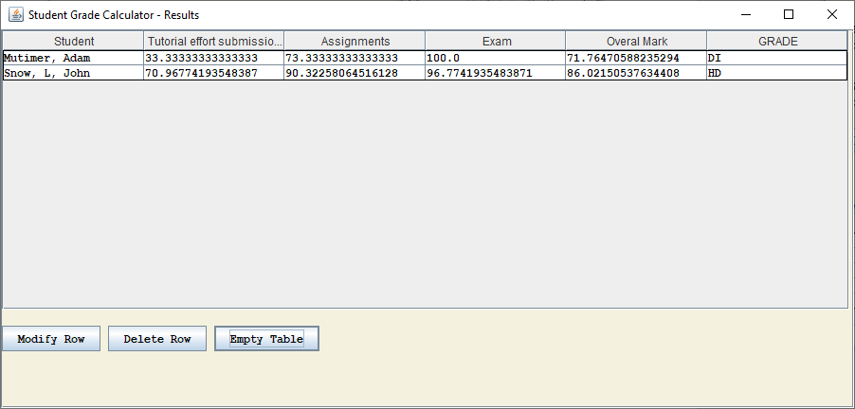

# Delete a Student and Their Grades:

Select the Student on the "Results" window:

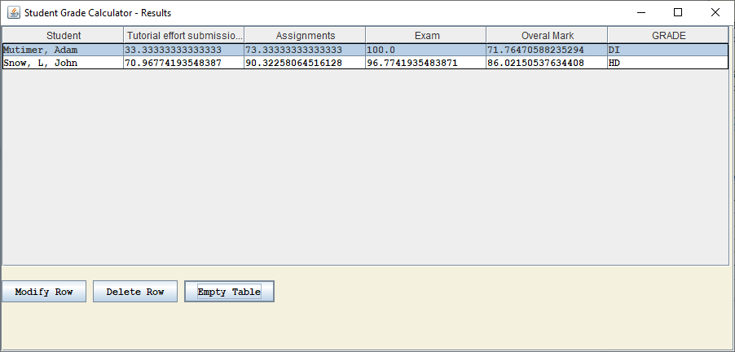

Followed by the "Delete Row" Button:

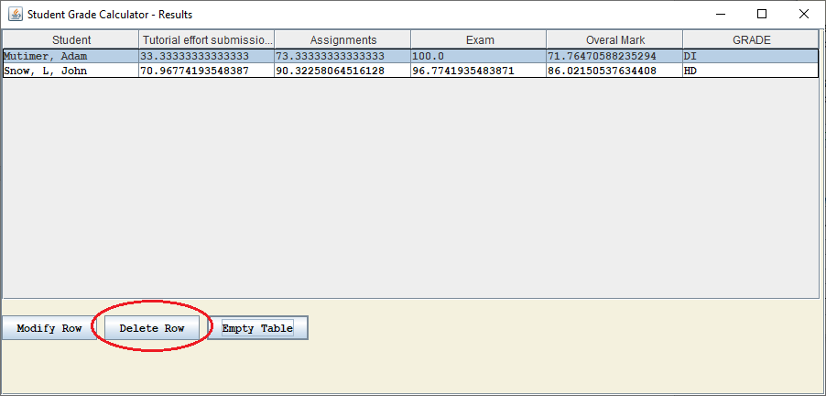

# Delete all Student and Their Grades:

To delete all Students, on the "Results" Window select the "Empty Table" button:

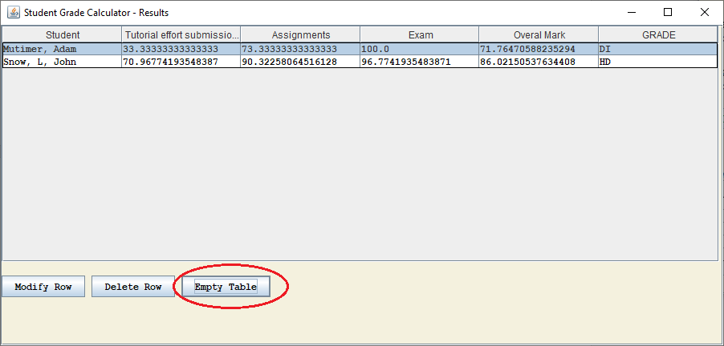

All Student information will now be deleted:

